Case 6-Afr-Mali-Mask-Dogon-Crocodile-19th c

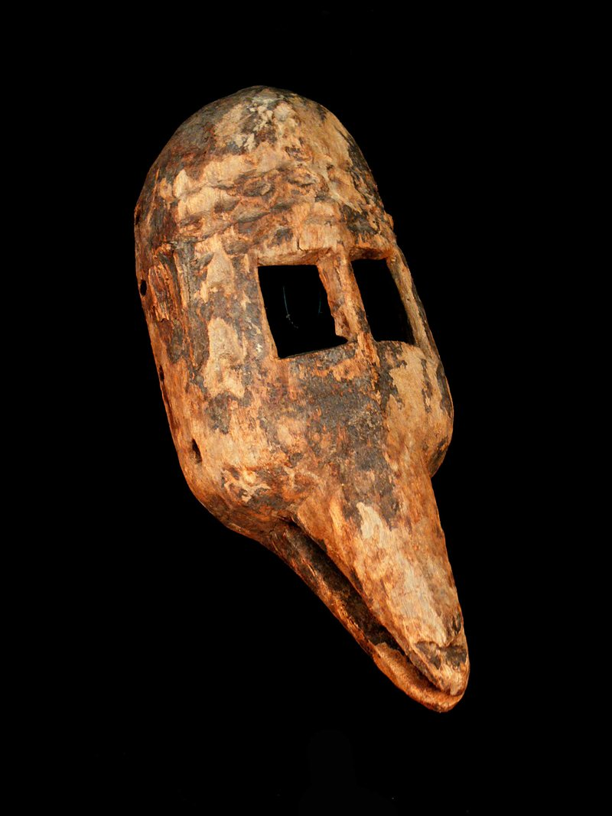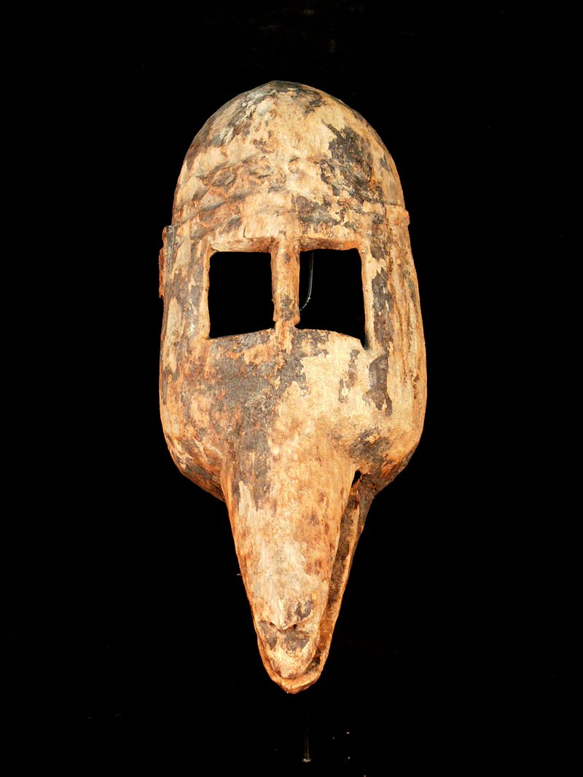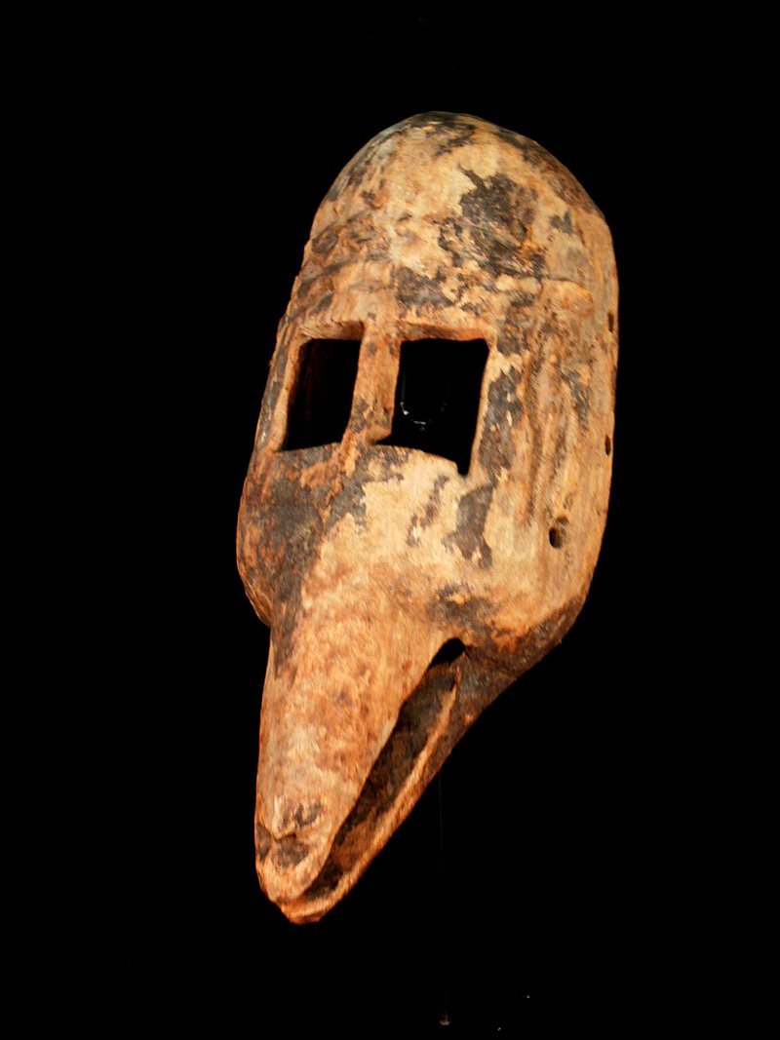

Crocodile Mask: Size : 14.960 inches, Weight : 2.408 pounds

Crocodile pirougue: : 4.3 x 12,2 in. / 11 x 31 cm.; 1.4 kg.

The mythic Dogon mythic crocodile is represented by a horizontal mask with a long, toothed mouth. Although there are eye holes on this mask, the dancer wears it on the top of the head and looks out through the open mouth. The dancer wears a red dance kilt, with an aureole of fibers and carried two dance staffs (DeMott 1979: 108-109). The movements of the crocodile are designed to communicate strength and beauty as well as mastery over the water.

Although the crocodile is the major predator of man in west Africa, as a totem animal of certain clans, it was considered as a benevolent protector of clan members from drowning. This is related to its positive role in folklore as an overseer of ponds inhabited by water deities, for, although water deities were associated with the life-giving water of their realm, they could also transform themselves into beautiful humans and lure the unsuspecting into their watery abyss to drown them (Dieterlen and de Ganay 1942:13-15).

The crocodile dance encompasses mythic tensions to revealed the sense of objective danger. The crocodile dancer gnashes his teeth, groans and cries in his predation on domestic animals while at the same time is benevolent to humans (Griaule 1963: 507-509). Inserted into the mouth of this mask would have been porcupine quills for teeth , since the porcupine is one of the animal sorcerers who are believed to possess supernatural evil powers by carrying lethal medicines in their stomachs which are released if killed , inflicting death on the hunter's family (Diangouno Dolo 1977 in DeMott 1979: 109). In order to emphasize the ambivalence of the crocodile's cosmic role, the crocodile dancer has an established place in the dance sequence and wears a refined costume of aureole, kilt and ruffs that contrast with its fearsome mask .

These ambivalent features are captured in the Dogon mask presented here and in the crocodile wedding pirogue, with the crocodile totem protecting the dual wedded couples on their wedding journey on the Niger River.

References:

DeMott, Barbara.1979. *Dogon Masks: a structural study of form and meaning*. Ann Arbor: UMI Research Press.

Dieterlen, G and de Ganay, S. 1942. Le génie des eaux chez les Dogon, *Miscellanea Africana*, Cahier 5: 48.

Griaule, Maurice. 1963 (1938). *Masques Dogons*, Travaux et Mémoires de l'Institut d'Ethnologie, 33, Musée de l'Homme, Paris.

